Salesforce – Overview

As Salesforce started as a cloud based solution for CRM, lets understand some details about CRM. **CRM** stands for Customer Relationship Management. It involves managing all aspects of relationship between an organization and its customers. For example the contact details of the customer, the deals that are in progress or already completed, The support requests from a customer or a new lead from a new customer. Beyond the customer related information it also involves storing and managing the details of the people and department from the seller organization who is managing the customer’s account and needs. This makes it easy to manage and enhance the relationship with the customer and hence better growth for the organization.

To achieve all the above the Salesforce platform has the following features

* **Contact Management** - To view customer contact details, activity history, customer communications, and internal account discussions etc. In short it manages all the data pertaining to the contact with a customer.
* **Opportunity Management** - It provides the details of the stage a deal is in, what products are involved in the deal, the quote in the deal etc. In short it manages all the data that helps in identifying, progressing and closing a deal.
* **Salesforce Engage** - This feature is focused on making personalized contact with a customer for various campaigns designed by marketing team. It also provides real-time sales alerts based on the level of engagement with a customer.
* **Sales Collaboration** - This feature helps in quickly finding experts who can help in closing a deal based on customer queries and feedback. In short, it helps in bringing in a collaborative effort to engage an entire team in the deal and make the deal happen.
* **Sales Performance Management** - It provides a metric-based goal settings, continuous feedback and rewards and recognition for the sales team. Which in turn helps in a better management of the performance of the sales team.
* **Lead Management** - To initiate and track the leads that are in progress. Also help in continually optimizing campaigns across every channel.
* **Partner Management** - Build a community with partners. Connect directly with channel partners to share goals, objectives, and activities.
* **Salesforce Mobile App** - This is the mobile platform to carry out all the above activities in a mobile platform.
* **Workflow and Approvals** - It is a visual design to automate the business processes. The interface provides simple drag and drop options to make this design. It helps in creating a flexible approval process with deal discounts and expense management etc.
* **Email Integration** - Salesforce can integrate to an existing email platform providing flexibility to the existing team with no additional learning curve.
* **Files Sync and Share** - This feature provides the sales team the power to easily share various files, discuss them and update them as needed. Also receive alerts when something in the file changes.
* **Reports and Dashboards** - Dashboards offer a real-time picture of the business at a glance. Also anyone can create detailed reports which can be accessed from anywhere.
* **Sales Forecasting** - This feature helps in getting a real time view of the forecast of a sales team. It provides multi-currency support and in-line editing mode to manage the sales forecast well.
* **Territory Management** - This feature is used to create multiple territory models, preview them before rollout, and continually optimize and balance territories throughout the year.

Salesforce – Architecture

Salesforce delivers a highly customized experience to the customers, employees, and partners of an organization. Such a platform is used to customize standard functionality and create custom pages, components, apps etc. Also it is done faster, mainly because of the superb architecture on which it is built. Below is a brief introduction to the Salesforce Architecture.

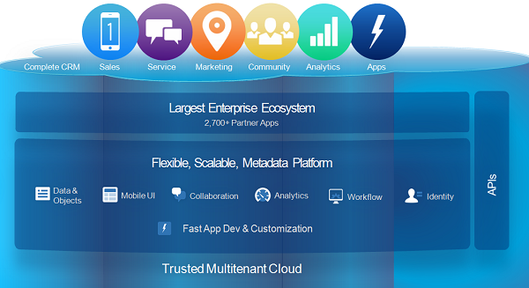

Architecture Layers

The architecture can be understood easily by imagining it to be layers of software on top of each other and communicating among themselves. The picture below represents those layers. The purpose and function of each layer is described below it.

* **Trusted Multitenant Cloud:** Here multiple instances of one or multiple applications operate independently in a shared environment. The instances are referred as tenants and they logically separate from each other while physically remain in the same hardware. It is called trusted because of both its robust nature and high security.
* **Scalable Metadata Platform:** The metadata driven platform makes it easy for customization and scaling up as the amount of data or concurrent user instances increases.
* **Enterprise Ecosystem:** Its Enterprise Ecosystem is very large as large number of partners contributes by creating and maintaining applications in this platform.
* **CRM and Related Functionality:** Salesforce include all aspect of CRM in its list of features and also extends it by providing features for creation of apps and integrating analytics etc.
* **APIs:** Salesforce provides powerful suite of APIs, which helps to develop and customize the Salesforce1 Mobile App.

Salesforce - Sales Cloud

It is a part of Salesforce.com platform which is focused on enhancing the effectiveness of the sales team of an organization and hence increase the amount of sales. It’s uniqueness as compared to other sales methods is it provides both the account information of the customer as well as the information gathered from the social platforms about the product and customer. This helps in correctly judging the potential of a sales lead and closing the sales faster.

Below are the Key **business Goals** achieved by using Sales cloud.

* **Close more deals** – The availability of all the account information as well as product information for customer’s needs makes it easier to drive more number of leads to closure.
* **Close deals faster** – Mobile apps and visual design of the workflows for business process approvals makes it faster to close the deals.
* **Get more deals** – Continuous optimization of campaigns depending on the market response and closure interaction with channel partners gets more deals.
* **Quicker decisions** – The availability of reports and dashboards gives a very detailed picture of the business scenario and also increase accuracy of sales forecasting. So the business decisions are taken quickly.

Key Features of sales cloud

* **Contact Management**: Gives complete information on customers including previous communications, discussions, key contact numbers and emails.
* **Opportunity Management**: It helps create and change quotes in response to sales interaction and deal scenario.
* **Salesforce Engage**: Gives alerts on active leads and create personalized campaigns.
* **Lead Management**: Helps assign leads to right people and track the campaigns.
* **Reports and Dashboards**: Helps create dashboards which can be drilled down for further information. This leads to faster decisions.
* **Sales Forecasting**: Gives accurate view of sales forecasting which can be adjusted based on real-time data.
* **Workflow and Approvals**: Helps simplify the approval process and automate any business process using visual drag and drop interface.
* **Territory Management**: Create different territory models and apply rules on them.
* **Files Sync and Share**: Search, share and find files faster. This leads to greater collaboration.
* **Sales Performance Management**: Helps create a link between sales data and sales goals. Also easily create the performance summaries.
* **Partner Management**: Easily connect with partners and give them a view of sales performance. Easily onboard, train and support sales partners.

Salesforce - Service Cloud

This part of Salesforce platform is focused on providing support and help to the customers. This helps in retaining the customers, increasing their satisfaction and loyalty. Its uniqueness lies in providing faster service compared to traditional methods, giving individual attention to each customer needs and take a proactive approach to customer issues. That ultimately enhances the customer’s experience hence loyalty which in turn creates a good impact on sales.

Below are the Key **business Goals** achieved by using Service cloud.

* **Personalized Service**: Give each customer a good service experience based on their unique problems and history of purchases and complaints.
* **Always-on Service** - Make the service available 24/7
* **Multi-channel support** - Meet the customers on their preferred channels like mobile, phone, chat etc.
* **Faster support** - Managing various service needs from a single console helps in delivering support services faster.

Below are the **Key Features of service cloud** which make it possible the above business goals.

* **Console for Service:** It is a unified platform for managing all cases assigned to an agent so that it can help in prioritizing the tasks at hand. Also help give personalized experience to the customer of each case.
* **Knowledge base:** Customer interactions and resolutions are captured and organized in to a knowledgebase. This helps in faster issue resolution.
* **Social Customer Service:** As more and more customers connect with the organization through social media, this feature helps deliver service on the social media platform itself without asking the customer to visit separate web pages for interaction.
* **Live Agent:** Real-time online help is made available by using this chat service.
* **Mobile Platform:** Salesforce1 platform is the mobile platform to manage customer service from any device and any place.
* **Service Cloud Communities:** It allows customers to help themselves by helping each other. Many tools are available for self service on various trouble shooting needs.

Salesforce - Navigating Setup

The Salesforce developer uses the setup area to configure and customize the interface. It is also used to add and support other users, and build various other functionalities. There are many paths to reach the same setup button. In this tutorial we will see the most commonly used setup paths and configurations.

The Salesforce home page has both classic and modern Lighting user Interface. We are referring the modern lighting interface. All most all the features are available in both the classic and Lighting user interface.

Setup Location

The setup link is located in the top right corner of the page as shown in the picture below. Clicking on the setup home takes us to the set up home page.

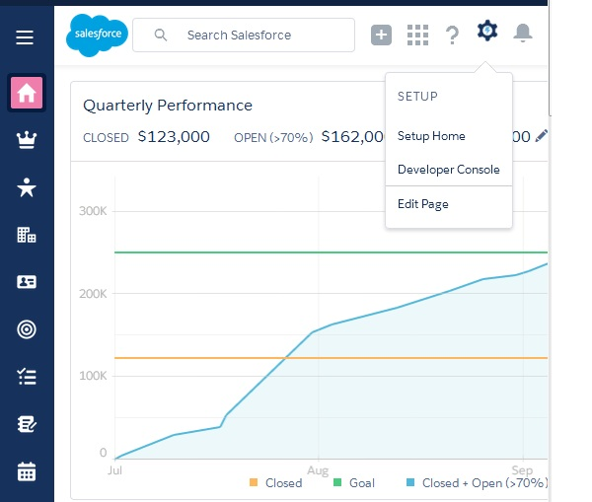

Setup Home

Below page shows the set up home where we see all the options available for the developer to configure and customize the option.

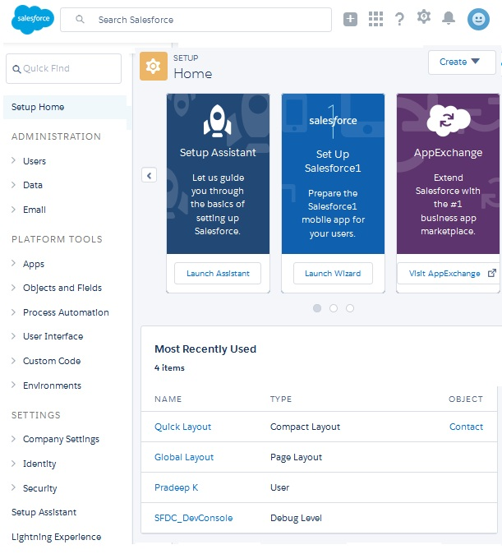

Setup Options

We have the below list of important features which are frequently used in setup activity.

|  |  |
| --- | --- |
| **Setting** | **Purpose** |
| **Users** | Create, Remove Users. Manage User profiles and Permissions. |
| **Company Settings** | Information related to your org. Like - Language, Maps and Locations, Domain etc. |
| **Security** | Expire Passwords, Access Policies, Session Management and Setup Audit Trails. |
| **Environment** | Jobs, Logs and Sandboxes. |
| **Objects and Fields** | Object Manager and Schema Builder. |
| **User Interface** | App Menu, Custom Labels and Lighting App Builder |
| **Custom Code** | Custom Metadata Types, Email Services, Remote Access etc. |
| **Analytics** | Reports and Dashboards |